Force & Pressure Notes

Force:
Push or pull on any object is said to be force.
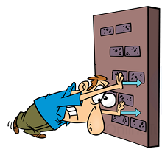

Push:
When an object moves away from the applier of force, the object is said to be pushed.

Pull: When object moves towards the direction of application of force than object is said to be pulled.

- Simply, we can define force as the physical cause which either changes or try to change the position, shape, size of any object.
- The interaction of one objects with the other also leads to the force between them.
- The magnitude and direction of force decides the effect of force.

Effect and application of force

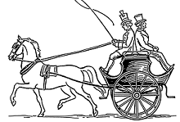

- When force is applied in the direction of motion of body then it adds up to the actual force. When force is applied in opposite direction of motion of a body then net force ithe difference of the two forces.
- Force can cause a body to move from rest.
- A moving body can be brought to rest after the application of force.
- Application of force can change the direction of moving body.
- It can change the speed of a moving body.
- It can also change the shape and size of body.

Contact forces
- Those forces which cause its effect by making contact with the object is said to be contact force. Some contact forces are given below.
- Take a look at it:

Muscular force
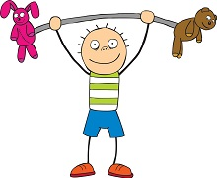

- Force which involves the action of muscles.
- Human, as well as animals, use muscular force to perform various tasks.
- By muscular force, a bullock is able to pull a cart.

Friction
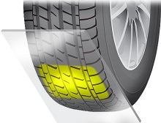

- To oppose the relative motion between two surfaces, when one surface is moving over the other a force which acts is said to be friction.
- Friction always opposes motion because it acts in opposite direction to motion.
- There would be no friction if there is no contact between two surfaces.
- Frictional force also depends upon the nature of the contact surface.

Non-contact force
- The force which can cause effect without making a contact with object is said to be non-contact forces.
- Let’s take a look at the different types of non-contact forces.

Magnetic Force:
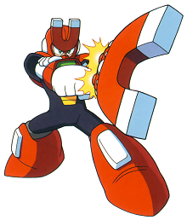
- The force applied by a magnet on any magnetic object is said to be magnetic force.
- A magnet can exert its force on an object even from a distance and does not need to touch that object. Iron, steel, cobalt etc. are some magnetic objects.
- The magnetic force may be attractive or repulsive.

Electrostatic force:
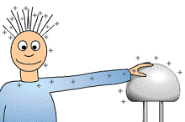

- The force which is produced due to electric charges is called electrostatic forces.
- This force exerted by a charged body on another charged or uncharged body
- Electrostatic force can also be attractive or repulsive.

Gravitational force:
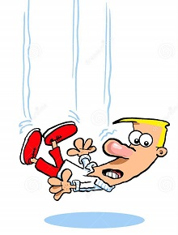
- Every object in the universe exerts a force on another object and this force is called gravitational force.
- The celestial bodies keep their defined position in the space due to the gravitational force of celestial bodies.
- It is attractive in nature and cause due to mass of the body.
- Any object, when thrown upwards, falls down to the earth’s surface due to gravitational force.
Pressure
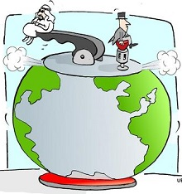

- Force acting per unit area is called pressure.
- Pressure = f o r c e / S u r f a c e A r e a o n w h i c h i t a c t s
- The unit of pressure is N/m2.
- We can also call it Pascal.
- Pressure is directly proportional to force.
- Area of surface is inversely proportional to pressure.
- So smaller the surface, higher will be its pressure.
- Liquids exert a force on the wall of container and effect of pressure increases with depth.
- At same depth in the container, the pressure is the same.
- Gases also exert pressure on the walls of their container.

Fluid:
- Pressure Exerted by Liquid and Gases
- Those substances which can flow is said to be fluid.
- Fluids include liquids as well as gases.
- At same depth, fluid exerts equal pressure.

Atmospheric Pressure
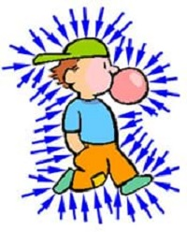
- This envelope of air surrounding the earth is known as the atmosphere.
- Atmospheric air extends up to many km’s above the earth’s surface.
- The pressure exerted by the air on any surface is known as atmospheric pressure.

